Practical File

of

Fundamentals of C Programming

23CS003

*Submitted*

*in partial fulfillment for the award of the degree*

# of

BACHELEOR OF ENGINEERING

*in*

COMPUTER SCIENCE & ENGINEERING



CHITKARA UNIVERSITY

CHANDIGARH-PATIALA NATIONAL HIGHWAY

RAJPURA (PATIALA) PUNJAB-140401 (INDIA)

May, 2024

Submitted To: Submitted By:

Dr. Preeti Sharma Komal

Assistant Professor 2310992042

Chitkara University, Punjab Sem-II (2023-2027)

# INDEX

|  |  |  |
| --- | --- | --- |
| Sr.  No. | Practical | Teacher Sign |
| 1 | Write a Program to show the use to input (Scanf)/output (Printf) statements and block structure of C-program by highlighting the features of "stdio.h". |  |
| 2 | Write a program to add two numbers and display the sum. |  |
| 3 | Write a program to calculate the area and the circumference of a circle by using radius as the input provided by the user.  . |  |
| 4 | Write a Program to perform addition, subtraction, division and multiplication of two numbers given as input by the user. |  |
| 5 | Write a program to evaluate each of the following equations.  (i) V = u + at. (ii) S = ut+1/2at2 (iii) T=2*a+√b+9c (iv) H=√b2+p2 |  |
| 6 | Write a program to swap two variable: a) By using temporary variable.  b) Without using temporary variable |  |
| 7 | Write a Program to find the greatest among three numbers using:   * Conditional Operator * If-Else statement |  |
| 8 | Write the following programs using switch case statement:   * To check that an input alphabet is vowel or consonant * To check whether a number is positive, negative or zero |  |
| 9 | Write a program using while loop to print the sum of first n natural numbers. |  |
| 10 | Write a program to check a number is Armstrong or not using For loop. |  |
| 11 | Write the program to count the digits in a number and then print the reverse of the number also. |  |
| 12 | Write a program to generate the Fibonacci series. |  |
| 13 | Write a program to print the following patterns: |  |

|  |  |  |  |
| --- | --- | --- | --- |
|  | a) * * *   * * * * * * * * * * * * * * * * * * | b) * * *   * * * * * * * * * * * * * * * * * * |  |
| 14 | Write the program to print the following pattern:   1. 2 3 4 5 6 2. 4 6 8 10 12 3. 6 9 12 15 18 4. 8 12 16 20 24 5. 10 15 20 25 30 6. 12 18 24 30 36 | |  |
| 15 | Write a program to check that the given number is prime, Armstrong or perfect using the concept of functions. | |  |
| 16 | Write a program to calculate the area and circumference of a circle using functions. | |  |
| 17 | Write a program to swap two variables using the concept of call by value and call by reference. | |  |
| 18 | Write a program to perform the following operations on 1D-Array:  • Insert • Update • Delete • Display • Search | |  |
| 19 | Write a program to calculate the sum of array elements by passing it to a function. | |  |
| 20 | Write a program to show the use of passing pointer as arguments to the functions. | |  |
| 21 | Write a program matrix multiplication using the concept of 2D array. | |  |
| 22 | Write a program to transpose a given matrix. | |  |
| 23 | Write a program to find the factorial of a number by using the concept of recursion. | |  |
| 24 | Write a menu driven C program to show the use of in-built string functions like strlen, strcat, strcpy, strcmp, strrev etc. | |  |
| 25 | Write a program to display the sum of the digits of a number by using the concept of recursion. | |  |
| 26 | Write a C program to add two distances in inch & feet using the concept of structures. | |  |
| 27 | Write a C program to add two complex numbers using the concept of structures in C | |  |
| 28 | Write a program in C to store the information of five employees using both concepts i.e. array of structure and array within structure. | |  |
| 29 | Write a Program in C to store and retrieve the information about students of a university by using the concept of file handling. | |  |
| 30 | Write a Program in C to find and replace a specific string in a file and also display the total number of appearances of that string. | |  |

Program 1: Write a Program to show the use to input (Scanf)/output (Printf) statements and block structure of C-program by highlighting the features of "stdio.h".

Solution:

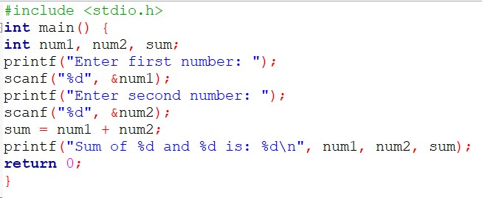

Output:

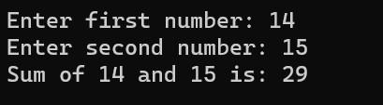

Program 2: Write a program to add two numbers and display the sum.

Solution:

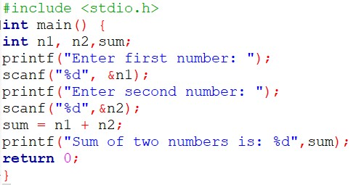

Output:

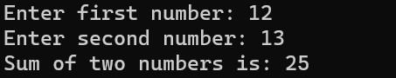

Program 3: Write a program to calculate the area and the circumference of a circle by using radius as the input provided by the user.

Solution:

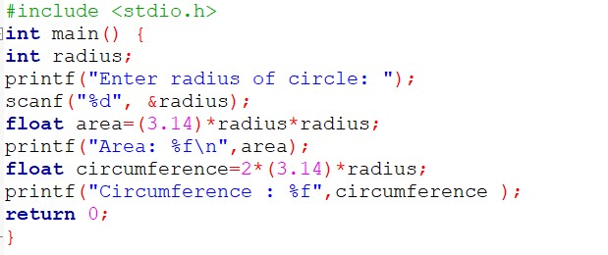

Output:

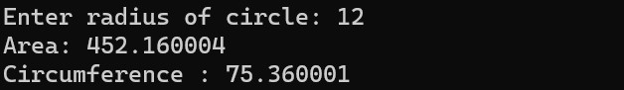

Program 4: Write a Program to perform addition, subtraction, division and multiplication of two numbers given as input by the user.

Solution:

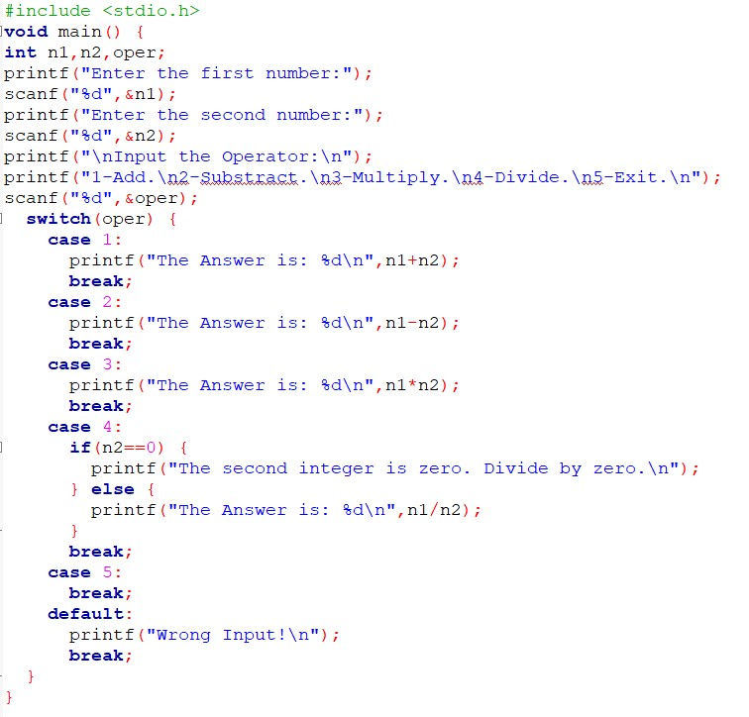

Output:

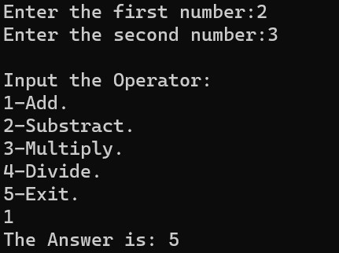

Program 5: Write a program to evaluate each of the following equations.

(i) V = u + at. (ii) S = ut+1/2at2 (iii) T=2*a+√b+9c (iv) H=√b2+p2

Solution:

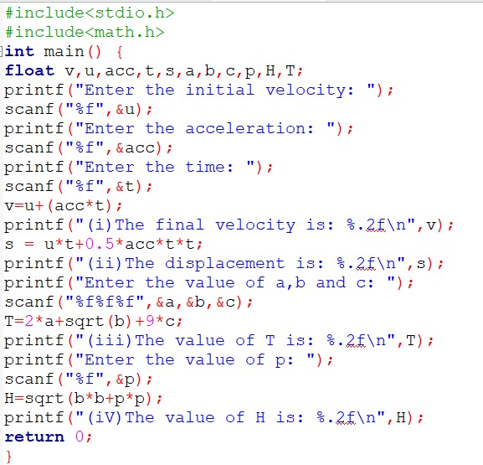

Output:

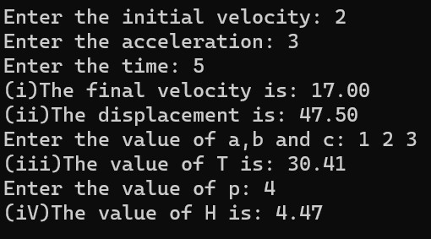

Program 6: Write a program to swap two variable: a) By using temporary variable. Solution:

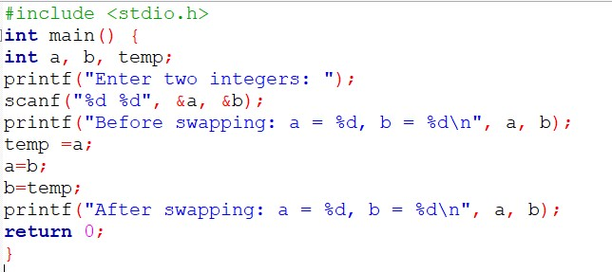

Output:

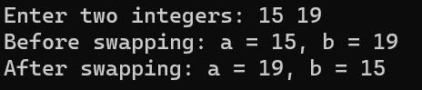

b) Without using temporary variable

Solution:

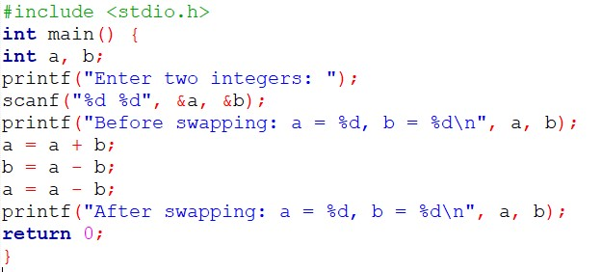

Output:

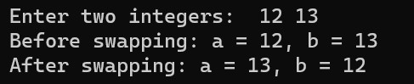

Program 7: Write a Program to find the greatest among three numbers using:

* Conditional Operator
* If-Else statement

Solution:

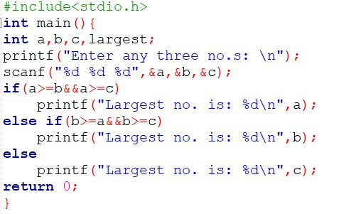

Output:

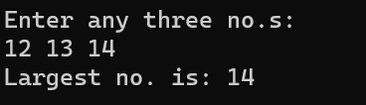

Program 8: Write the following programs using switch case statement:

* To check that an input alphabet is vowel or consonant Solution:

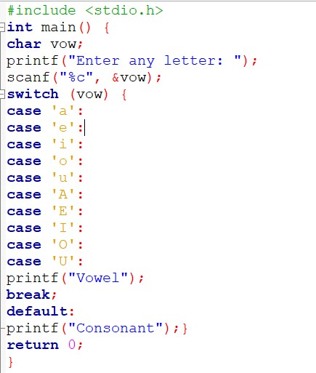

Output:

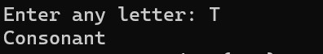

* To check whether a number is positive, negative or zero Solution:

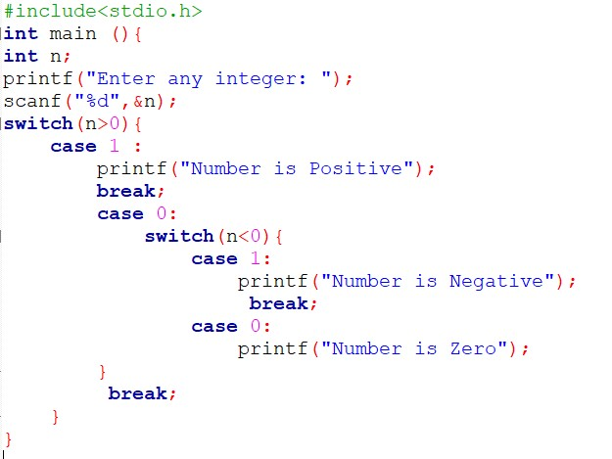

Output:

Case 1:

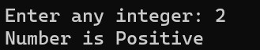

Case 2:

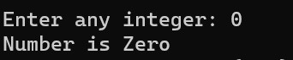

Case 3:

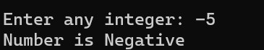

Program 9: Write a program using while loop to print the sum of first n natural numbers.

Solution:

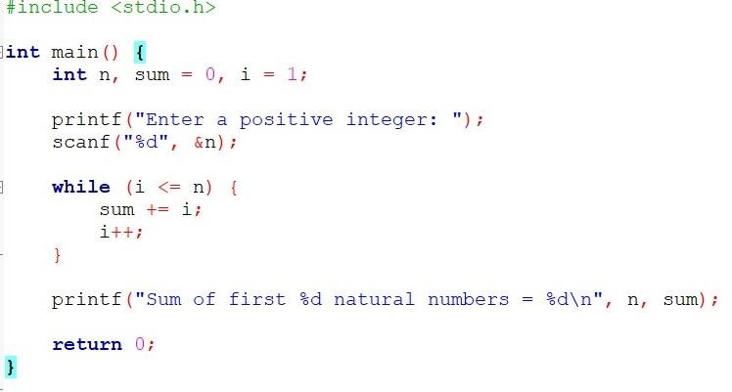

Output:

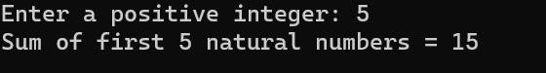

Program 10: Write a Program to check a number is Armstrong or not using For loop.

Solution:

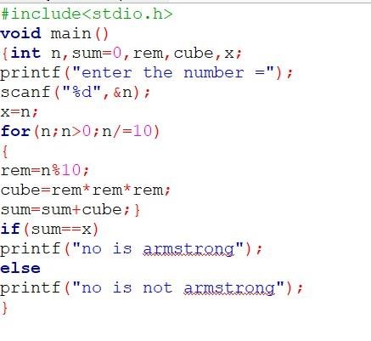

Output:

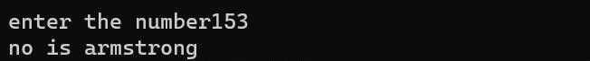

1: Write a Program to count the digits in a number and then print the reverse

of the number also. Solution:

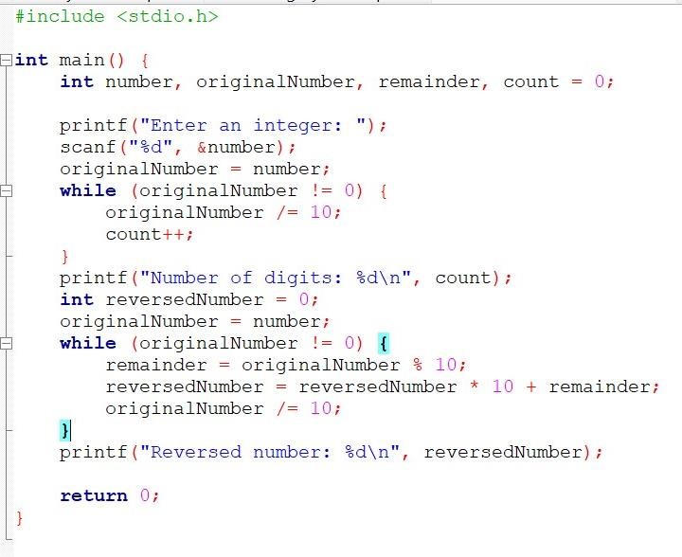

Output:

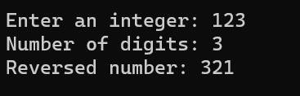

Program 12: Write a program to generate the Fibonacci series. Solution:

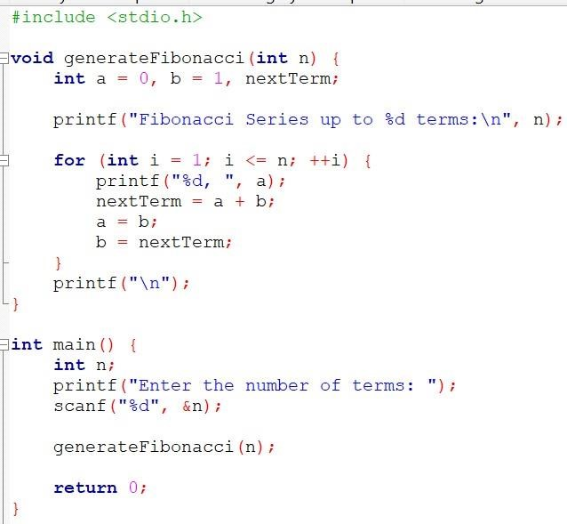

Output:

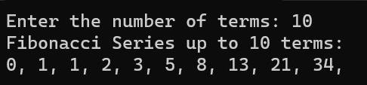

3: Write a program to print the following patterns:

|  |  |
| --- | --- |
| a) *   * * * * * * * * * * * * * * * * * * * * | b) * * *   * * * * * * * * * * * * * * * * * * |

Solution:

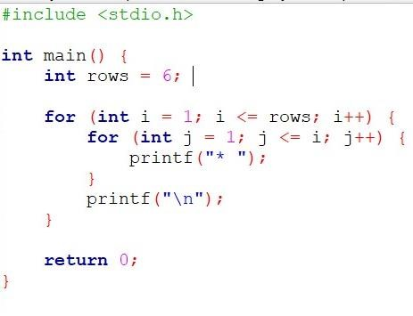

Output:

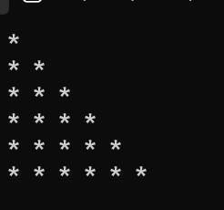

4: Write the program to print the following pattern:

1. 2 3 4 5 6
2. 4 6 8 10 12
3. 6 9 12 15 18
4. 8 12 16 20 24
5. 10 15 20 25 30
6. 12 18 24 30 36

Solution:

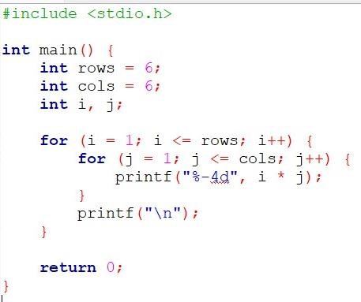

Output:

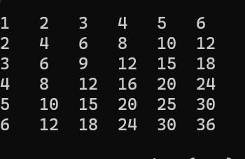

5: Write a program to check that the given number is prime, Armstrong or

perfect using the concept of functions. Solution:

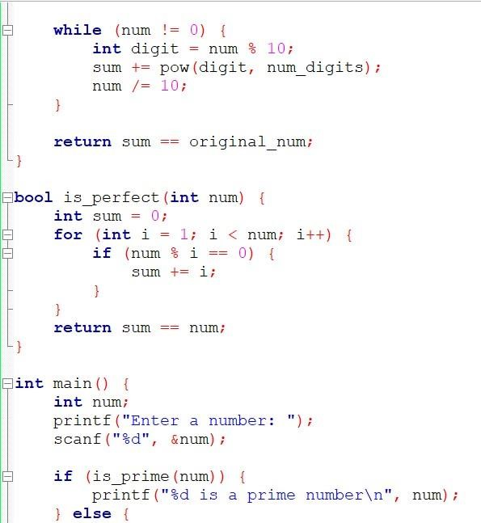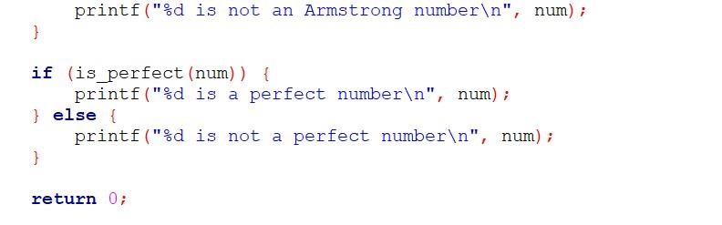

Output:

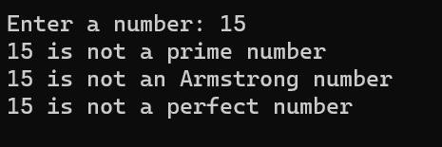

6: Write a program to calculate the area and circumference of a circle using

functions. Solution:

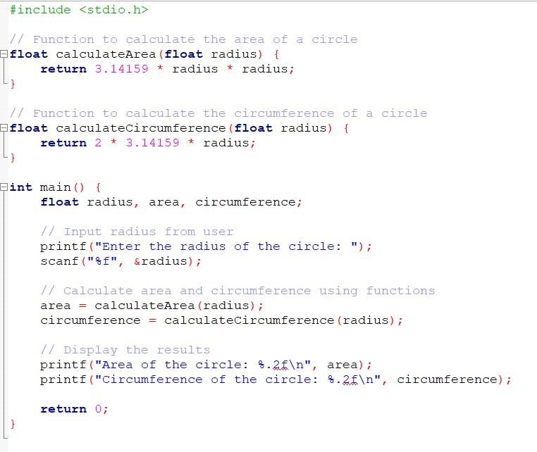

Output:

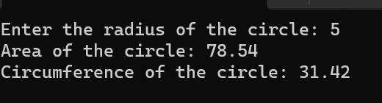

7: Write a program to swap two variables using the concept of call by value

and call by reference. Solution:

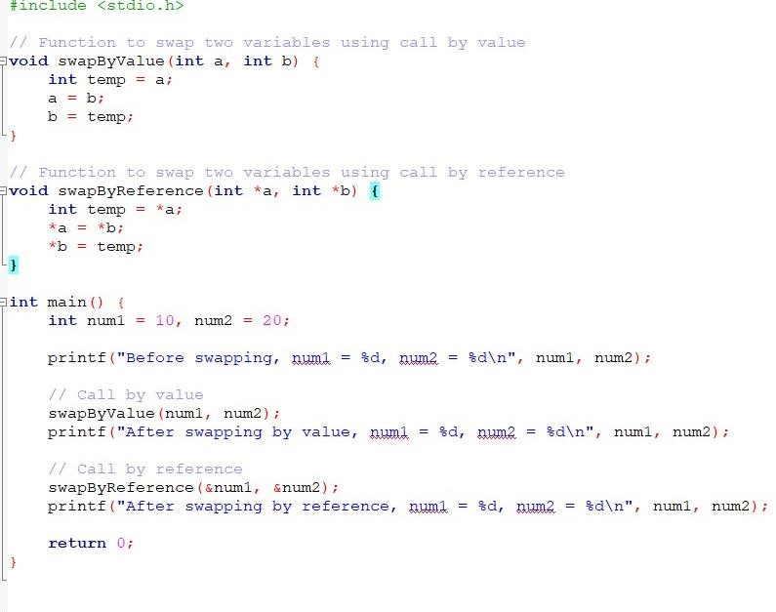

Output:

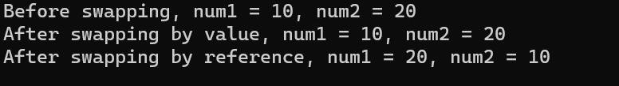

8: Write a program to perform the following operations on 1D-Array:

• Insert • Update • Delete • Display • Search Solution:

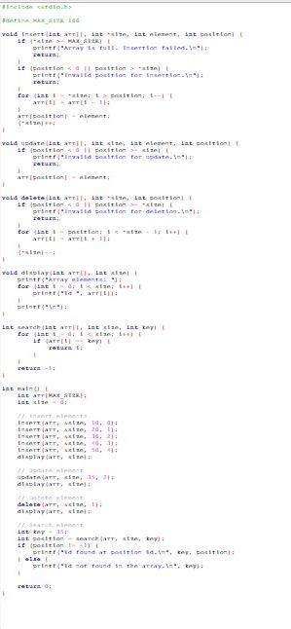

Output:

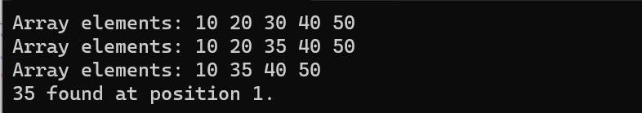

9: Write a program to calculate the sum of array elements by passing it to a

function Solution:

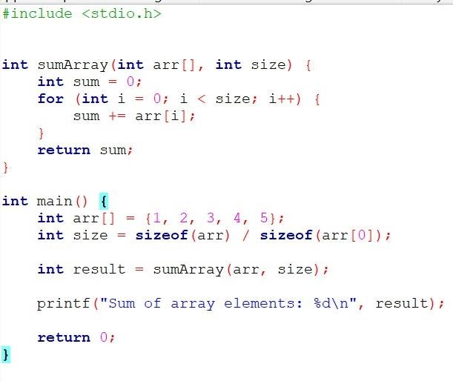

Output:



Program 20: Write a program to show the use of passing pointer as arguments to the functions.

Solution:

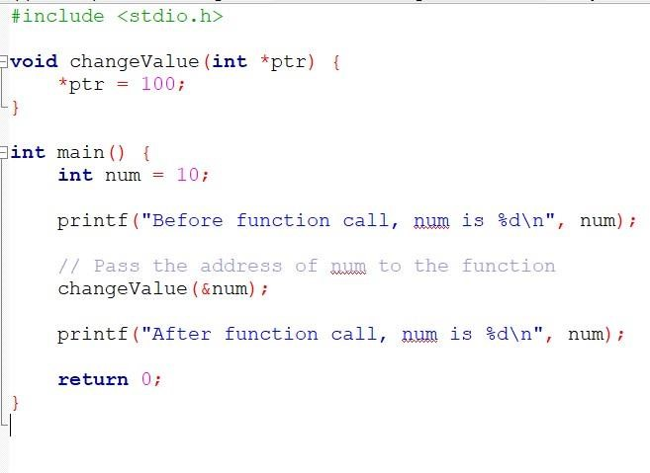

Output:

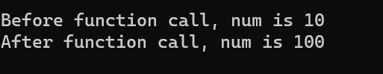

Program 21: Write a program matrix multiplication using the concept of 2D array

Solution:

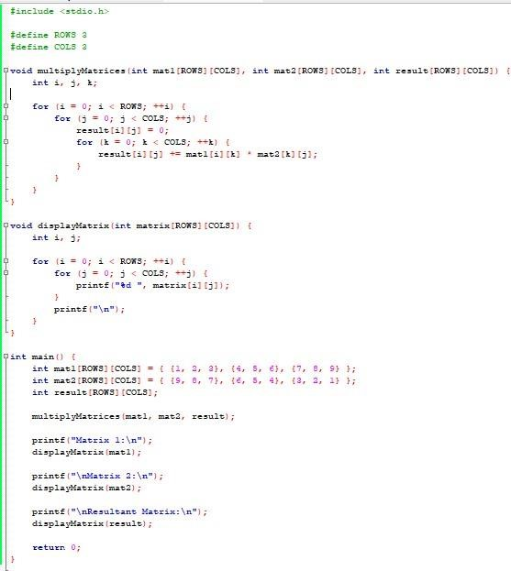

Output:

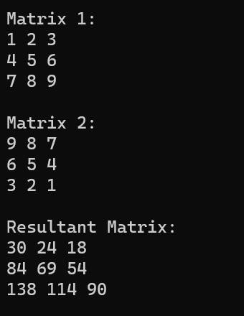

Program 22: Write a program to transpose a given matrix. Solution:

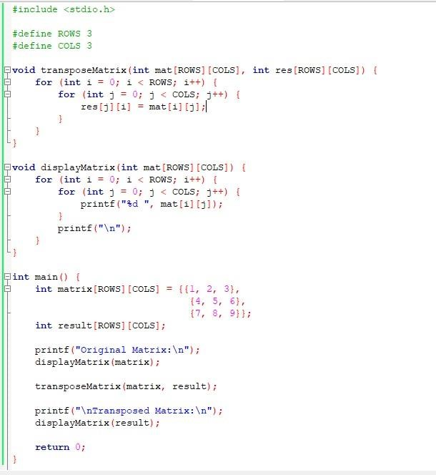

Output:

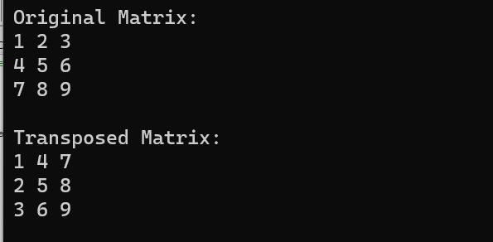

Program 23: Write a program to find the factorial of a number by using the concept of recursion.

Solution:

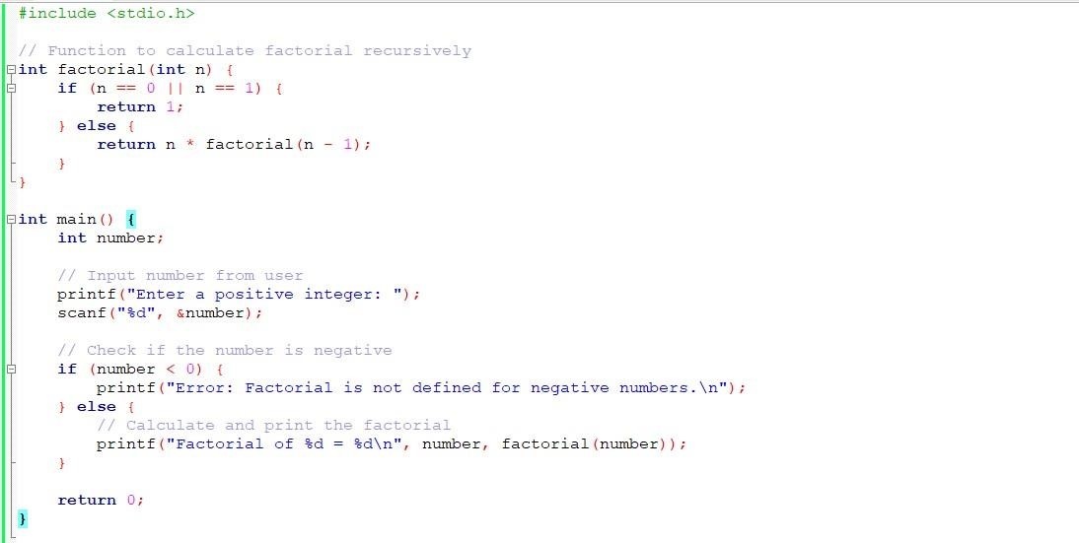

Output:

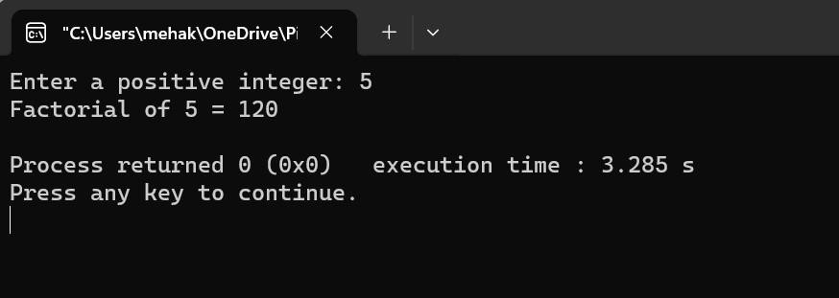

Program 24: Write a menu driven C program to show the use of in-built string functions like strlen, strcat, strcpy, strcmp, strrev etc.

Solution:

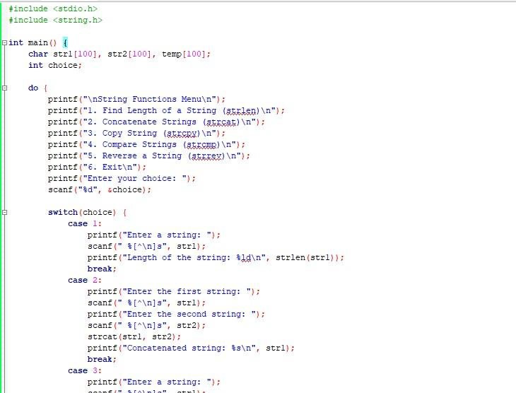

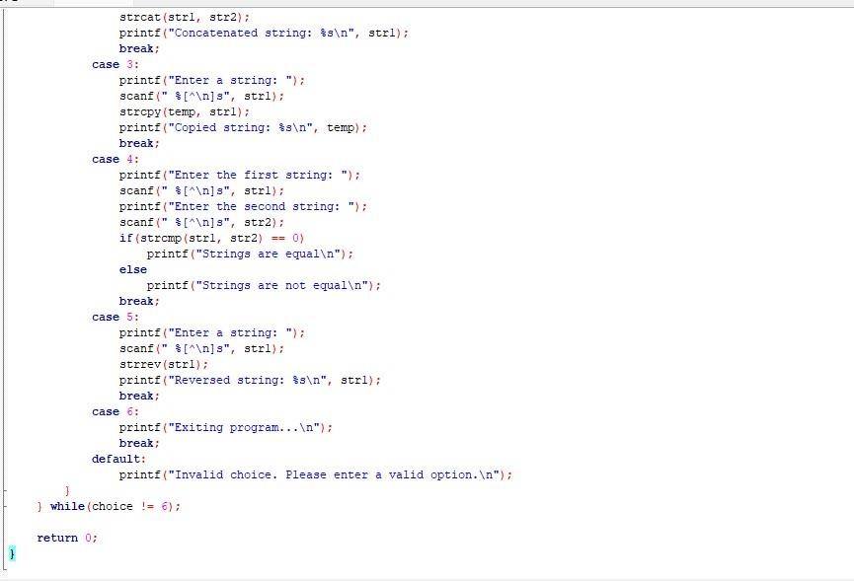

Output:

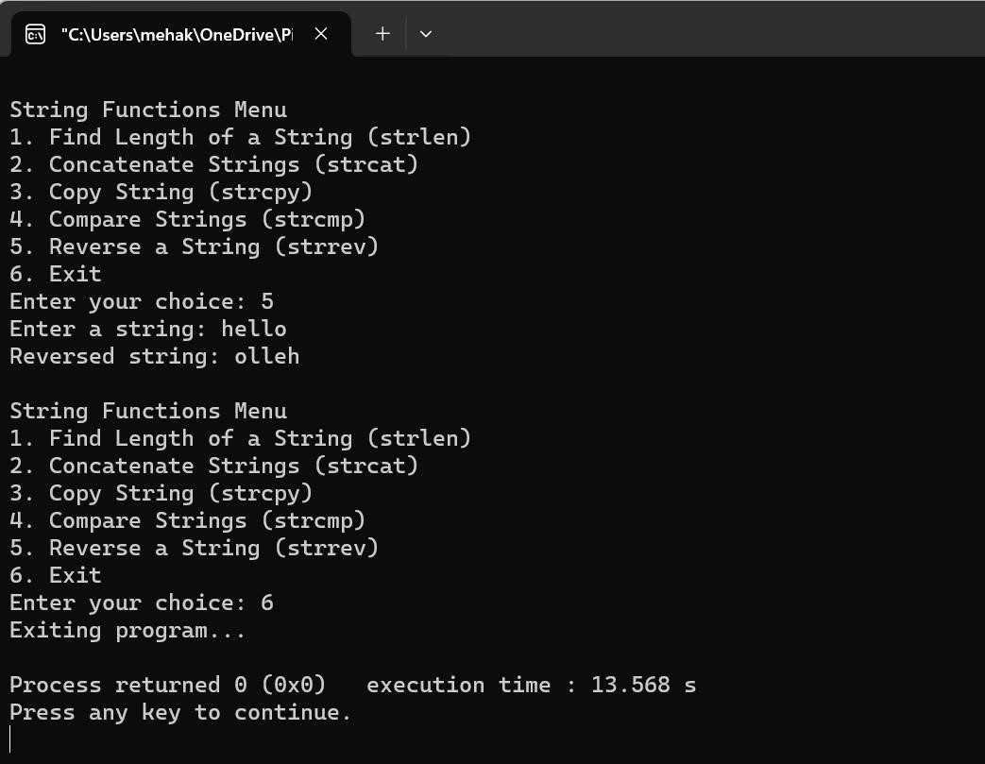

Program 25: Write a Program in C to display the total number of appearances of a substring provided as input by the user in a given string.

Solution:

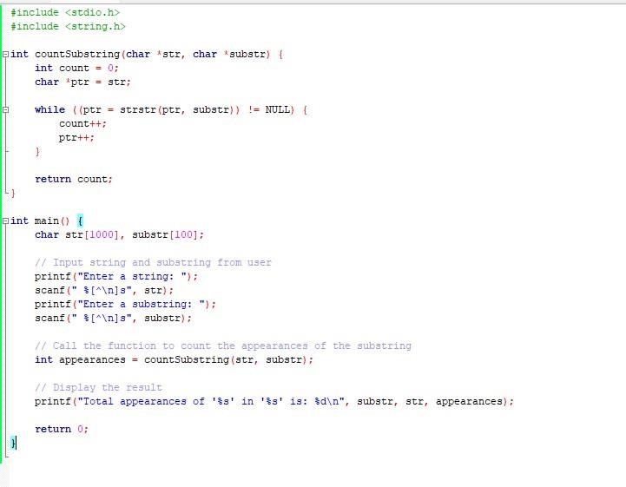

Output:

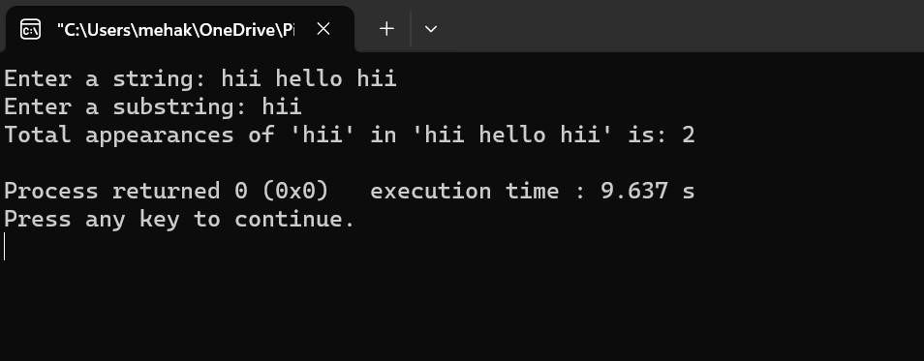

Program 26: Write a program to display the sum of the digits of a number by using the concept of recursion.

Solution:

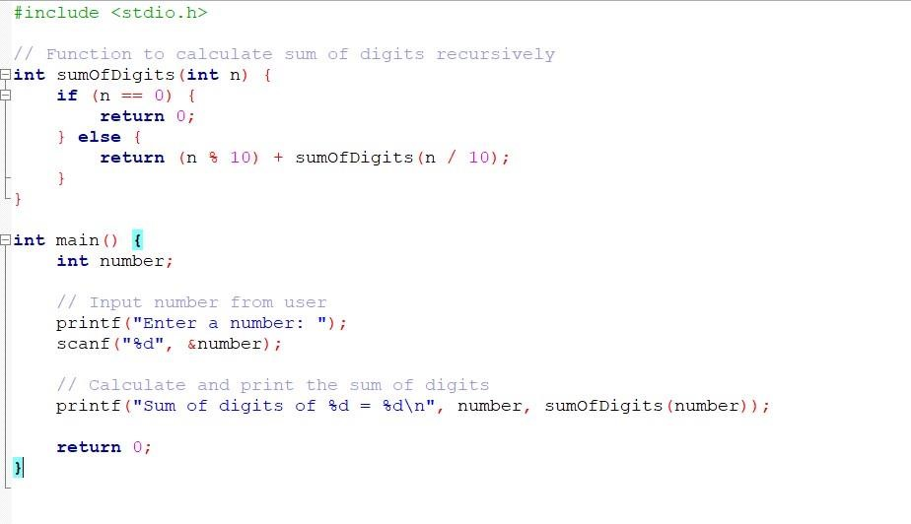

Output:

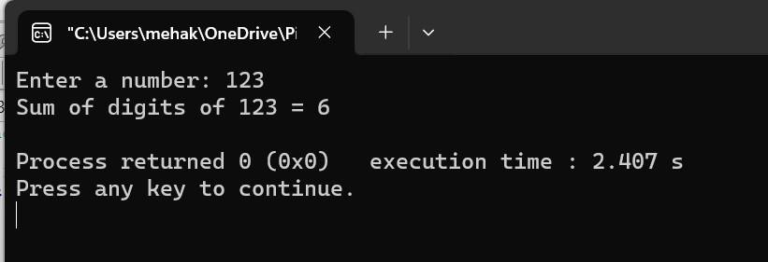

Program 27: Write a C program to add two distances in inch & feet using the concept of structures.

Solution:

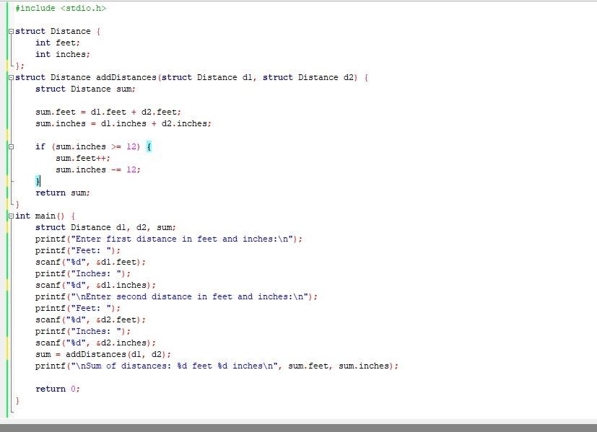

Output:

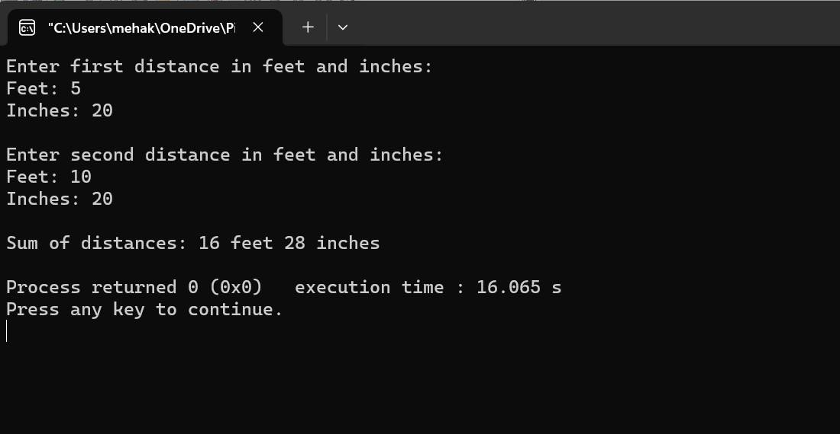

Program 28: Write a C program to add two complex numbers using the concept of structures in C.

Solution:

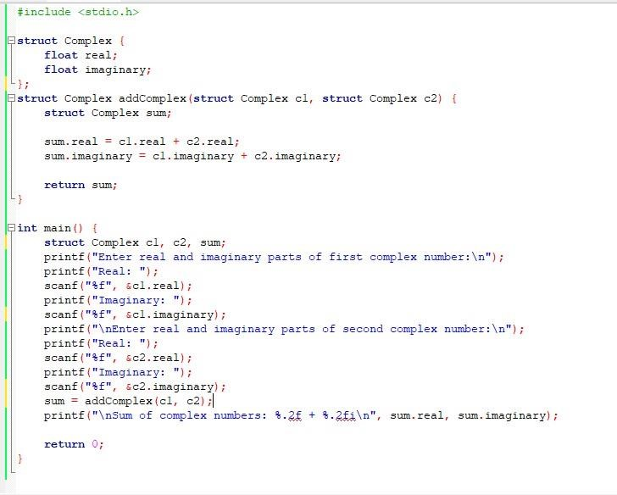

Output:

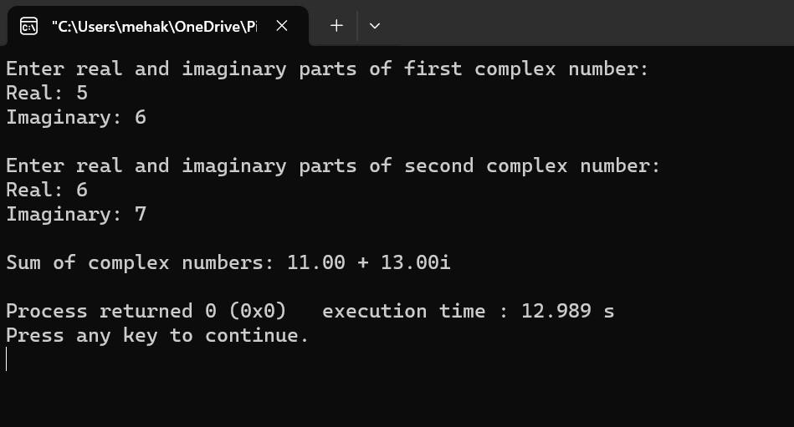

Program 29: Write a program in C to store the information of five employees using both concepts i.e. array of structure and array within structure. Solution:

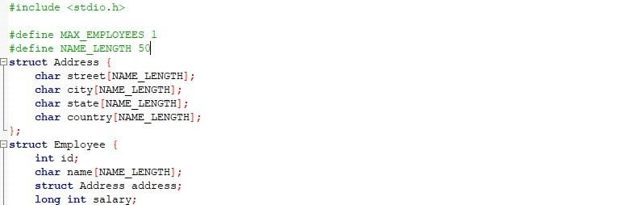

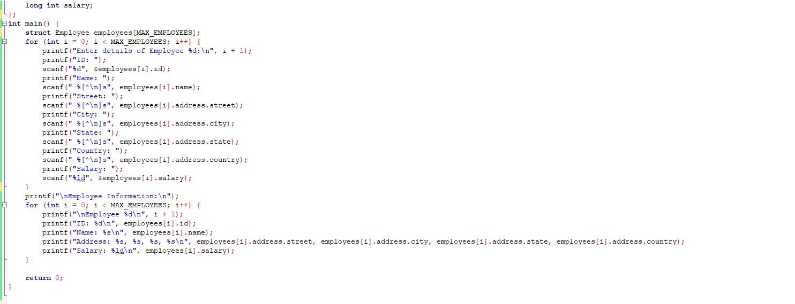

Output:

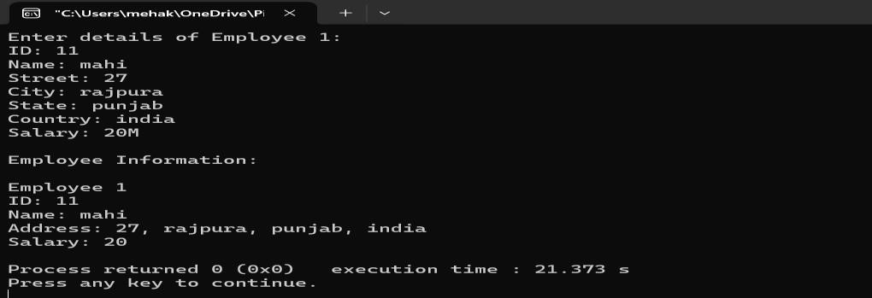

Program 30: Write a Program in C to find and replace a specific string in a file and also display the total number of appearances of that string. Solution:

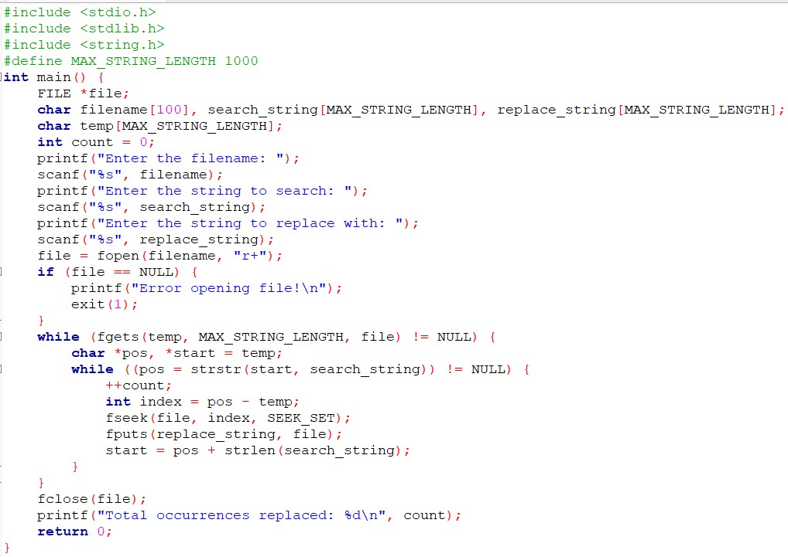

Output:

